

**FRODSHAM PRIMARY ACADEMY - HEALTH EATING STATEMENT**

At Frodsham Primary Academy, we believe that proper nutrition and fluid intake are essential for all children to be prepared for and to take part in learning. Therefore we want to play our role in establishing and maintaining lifelong healthy eating and drinking habits.

We pride our self on providing a happy, secure, stimulating environment for all children to be able to learn and access the curriculum. If a child is not healthy and their body is not receiving the right nutrients and fluids they will find the school day a struggle. It is therefore our aim and vision to:

* teach from a curriculum that informs the children about their growing bodies, its needs and what it means to be healthy
* to equip them with the knowledge to make informed choices both at school and home.
* to involve the whole school in developing and maintaining healthy eating and drinking habits.
* to have a pleasant and sociable dining experience which enhances the social development of all children.
* to encourage fluid intake with an easily accessible water supply throughout the day.
* to take into account and accommodate dietary requirements.
* to ensure high standards of hygiene amongst the children.
* to have as many staff as possible in EYFS and Nursery to have food handling/hygiene knowledge and certification (for preparing snacks).
* to involve the community around us to help and assist with the teaching of our aims.
* to encourage parents to support the school in establishing good eating and drinking habits. Nutritionist advice to support parents is available before children access the provision.
* Ensure all children in EYFS and KS1 take up the free school meal option. This is clearly communicated to parents on the child’s entry to school
* we ensure that all children feel safe with the menus and food within the school, and that we do everything possible to accommodate children’s specialist dietary requirements including allergies, intolerances, religious or cultural practices as a result, we are a **NUT AWARE SCHOOL**

# Meals throughout the day

* Breakfast is an important meal that should provide 25% of a child’s energy requirement and support children to be ready to learn at the start of each day. The school runs a daily breakfast club which can be accessed from 7.45am for a small fee. More details and applications can be accessed via the school office.
* School meals are provided by Edsential and served between 11.50am and 12:45pm in the dining hall. The school meals meet the mandatory requirements of the School Food Standards 2015. School meals are planned on a 3 week cycle and always contain a vegetarian option. The school meals menu can be found on our school website and is regularly shared with our school newsletter. Children can view the menu in the class for the day and the day ahead, and can order their meal through the class teacher.
* Packed lunches: We aim to support parents and children in making healthy decisions when it comes to their packed lunches. For this, we have modelled our guidance on the Eatwell Guide [(https://www.nhs.uk/live-well/eat-well/the-eatwell-guide/ )](https://www.nhs.uk/live-well/eat-well/the-eatwell-guide/). The guidance aims to support pupils to have a balanced lunch and best prepare them for learning in the afternoon.
* Packed lunches **should aim to include**:
* Some starchy foods such as bread (sliced bread, pitta bread, wraps, bagels), pasta, potatoes, couscous; choose wholegrain where possible

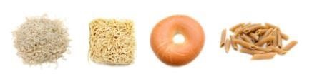

* At least 1 portion of fruit and 1 portion of vegetables or salad



* Dairy food such as cheese or yoghurt

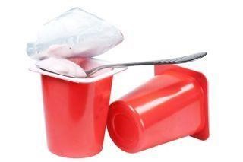

* Meat, fish, or another source of protein such as eggs, beans and pulses, hummus



* Oily fish once every 3 weeks e.g. sardines or salmon

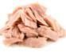

* Packed lunches **should not include**:
* Sweets
* Any high calorie, high sugar and high fat sweet products such as pastries and chocolate bars(e.g. mars, galaxy etc).



* Drinks at lunch time: Our school provides milk for pupils at lunchtime but it is recommended that children also have water with their packed lunch or school dinner. A small yogurt drink, fruit juice or smoothie is permitted – but remember, fruit juice and smoothies should be limited to a combined total of 150ml a day. You could always dilute fruit juice with water.
* Snacks: Our school understands that healthy snacks can be an important part of the diet of young people.
* In EYFS, the children pay a small amount of money each week for their snack. This snack is bought, prepared and served by the teacher or assistant, unless the children make and prepare their own snack as a classroom activity. In EYFS the children sit down to eat their snack at the table and are encouraged to have good table manners. Milk or water is provided to all children in EYFS.
* In KS1, a piece of fruit or vegetable is provided each day through the free fruit from schools scheme. Children who do not wish to have this snack in KS1 are welcome to use the toast scheme on offer at break time.
* In KS2 children have the option to purchase toast and juice or bring their own healthy option in.

Ideas for healthy snacks can be found at [https://www.nhs.uk/change4life/food-facts/healthier-snacks-forkids](https://www.nhs.uk/change4life/food-facts/healthier-snacks-for-kids)

*Some examples include malt loaf, fruit and vegetable snacks, rice cakes and nut free, high fibre/ protein rich snack bars.*

 

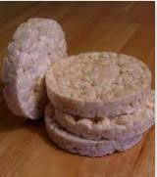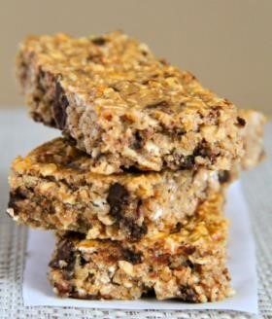

* Drinks throughout the day: Our school is a water only school, with the exception of the free milk at lunch time. Water is available throughout the day within all classrooms.
* Dietary requirements**:** The school does everything possible to accommodate children’s specialist dietary requirements including allergies, intolerances, religious or cultural practices. Individual care plans are created for pupils with food allergies. Pupil’s food allergies are displayed in a sensitive way around the school including in the dining hall and classrooms. We have posters located around the building to promote that we are a nut aware school.

# Appendix 1: Lunchbox builder from British Nutrition Foundation

