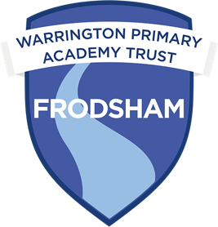
Frodsham Primary Academy

6th September 2024
Welcome to the first newsletter of this new school year.
We have had a fantastic, settled start to the school year. Children have started back exceptionally well and have all settled into their new class structures.
This week, we have spent time reminding children of our school values, rules, and routines. We are having a big focus on positive praise and reinforcement within school. We have reset our class Dojo and all Dojo points will be linked to our school rules. In addition to this, children get a Dojo for arriving at school on time every day. As another incentive, we have also introduced ‘WOW’ cards. These can be awarded by ANY member of staff within school when children are recognised for doing something over and above. Children are then rewarded back in class with 2 Dojo points. Children can spend their Dojos in our Dojo shop which will be open at the end of each half term.

Children in Year 1-6 should have received your family Dojo log in today. With this, you will be able to see when your child is awarded Dojo points and keep up to date with their positive praise. Children in EYFS will receive theirs next week, we want to ensure children fully understand the concept before we start awarding points.
As I am teaching in EYFS for part of the week, there will be limited days I will be available on the school gate as I will be opening for EYFS children. There will always be a member of staff for you to speak with.
I have added some initial dates for your diary onto the back page, but please keep a check as dates will be added over the next few weeks.

Have a great weekend,
Mrs Callaghan



Wednesday 17th 9.00-10.00am

Stars of the week

N: Freya
R: Adelayd
Y1: Harley
Y2: Lexy
Y3/4: Aria
Y5: Mason
Y6: Kyla
RP: Albert

Learning this week…

This week in Barn Owls, we have spent time welcoming each other back to school and meeting new friends who have joined us this September. We have enjoyed exploring the layout of our new classroom and learning in all the different areas.

All children have been having a good go at name writing this week. Children each have their own whiteboard with name card attached. They have been asked to write their name each morning when they enter the classroom. This will be a big focus for us this half term.

We have also enjoyed taking part in a children’s yoga session and our first PE lesson with Miss Greenhalgue. Next week, children will start their weekly forest school session with Miss Pemberton on Thursday mornings. This will be so much fun!

Well done for a fantastic start to the year, you have made us very proud.

Mrs Callaghan

Snowy Owls have come back to school with fantastic attitudes towards their learning and brilliant confidence too!

The children have been looking back at all their learning from last year to see how much they can recall and then looking into their futures on what they want to be when they grow up. We discussed different careers and how our learning now will help us to achieve these goals.

In Maths, Year 1 have been learning all about careful counting up to 10 and Year 2 have been learning about counting up to 100 in 10s and recognising different numbers too.

I am really looking forward to the rest of this half term!

Miss Sands
I am so happy to be back with the children this year, they have already shown me in these last 3 days how amazing they all are and how they are ready to learn.

We have written letters from our future selves about all of their future achievements for this year. These will be displayed in the hall on mountains with photo's of them climbing to reach their goals.

The children have started their maths learning looking at place value in 4 digit numbers. They used physical resources to make the numbers in different ways.

Miss Curtis
We have had an amazing start to the school year in Year 5 and 6. The children have come back ready to learn and they seem to have grown in maturity. We have started the school year by reminding ourselves of the school rules and routines to make sure that we are settling the correct example across school.

We have been looking at the whole school text 'Oh the Places You'll go' by Dr Suess in English and we have been looking at what the text means to us as there are a lot of hidden meanings.

We have already started our maths lessons and we have looked at reading and writing numeral to 1 million and 10 million and Fridays we will be having dedicated time to problem solving in maths.

As a class we have recapped what the British Values are and what they mean to us. We have looked at how the different British Values are represented at Frodsham Primary Academy.

We have a 'Meet the Teacher' event on Monday at 2:30pm where you can find about all of the exciting learning opportunities that are planned for the Autumn term, so, please do pop along.

Mrs Price

Tawny Owls have been settling back into school and relearning their classroom rules and routines.

Children have explored both of their classrooms, the nest room, which is our new classroom, and the tree room that were already familiar with.

Children also recapped the zones of regulation, identifying emotions in each zone and coming up with some ideas to help us get back to the green zone.

Well done for a great start back to school

Miss Pemberton

School meals: Next week, Week 2
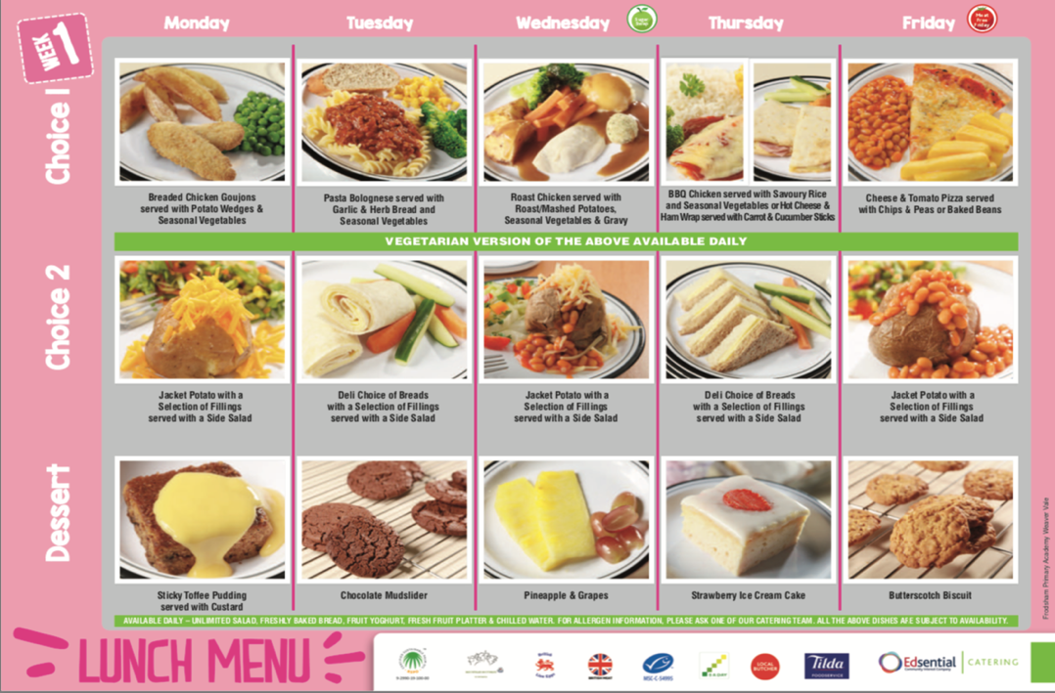
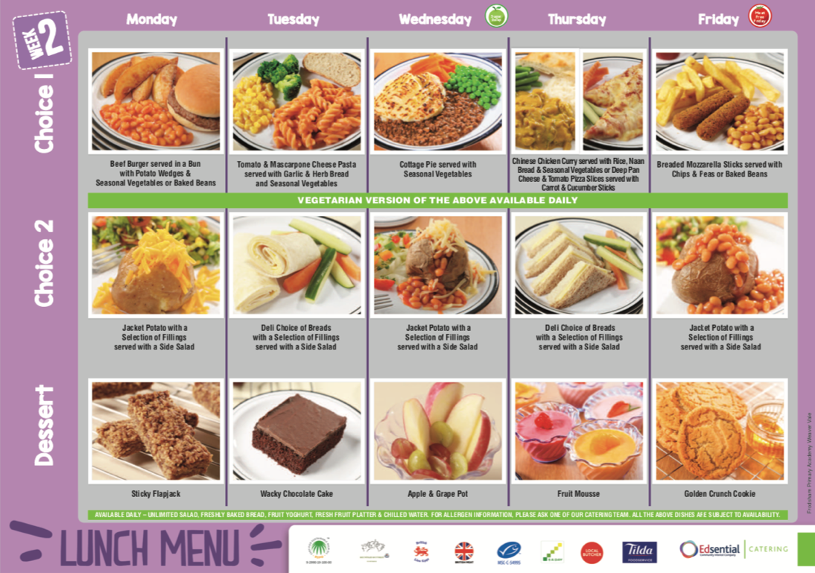

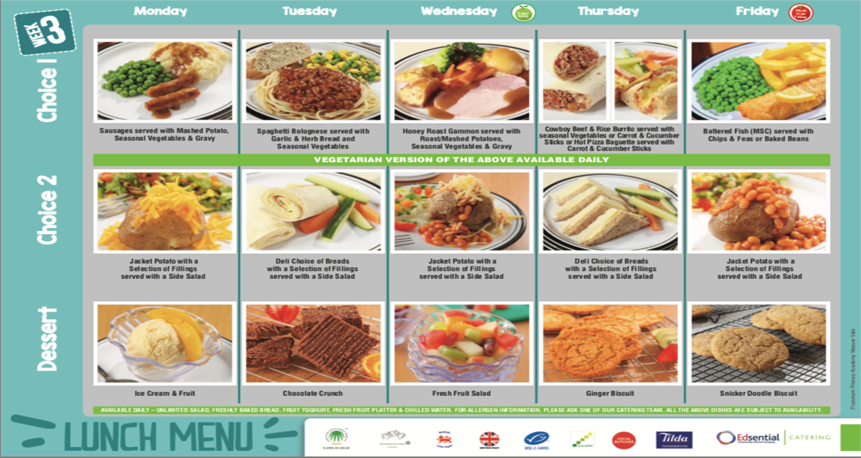
Diary of events for Autumn term
Wednesday 4th September | School reopens
Monday 9th September  2.30-3.00 | Year 5/6 curriculum information session for parents
Tuesday 10th September  2.30-3.00 | Year 1/2 curriculum information session for parents
Thursday 12th September  2.30-3.00 | Year 3/4 curriculum information session for parents
Friday 13th September  2.30-3.00 | Resource Provision curriculum information session for parents
Friday 27th September  9-10am | McMillan Coffee morning
Thursday 3rd October  MORNING | School photographs- Individual and sibling
Monday 14th October | EYFS stay and play for morning children only 10.30-11.30  EYFS stay and play for reception and full time nursery 2-3pm
Monday 14th October  3.30-4.00 | Class book look- All parents invited into classes
Monday 14th -16th October | Bike ability Level 1 and 2
Wednesday 16th October | PTA Halloween Disco
Thursday 17th October | Y3/Y4 Learn to ride session
Friday 18th October | Final Day- Finish at 3.20pm
Monday 4th November | Return to school
Friday 15th November | Interim reports go home
Monday 18th November | Parents evening for all classes
Thursday 21st November | Own clothes day- Bring a bottle
Thursday 28th November | Own clothes day- Bring chocolates or sweets
Thursday 5th December | PTA Christmas Bingo night 5.30-8.30pm
Monday 9th December | Christmas performance for Resource Parents ONLY
Tuesday 10th December | Christmas Performance  9.15am and 2.00pm
Wednesday 11th December  3.20-5.15 | PTA Christmas film night
Thursday 12th December | Christmas Pantomime Theatre Trip
Thursday 12th December  3.30-4.00 | End of term Book Look
Thursday 19th December | Resource Provision Pantomime Trip
Friday 20th December | Own Clothes Day/Party Day  Finish school at 1.20pm
Monday 6th January | Children return to school

Please take a note of term dates.
These are also on the school website

