Friday 26 May 2023

**NSPCC – The Childhood Day Mile – Friday 9 June 2023**

Dear Parents / Carers,

We are delighted to be supporting the NSPCC by taking part in The Childhood Day Mile this Childhood Day on **Friday 9th June**. Everything the NSPCC does protects children today and prevents abuse tomorrow. The NSPCC need our support more than ever. By raising money, we can help to fund their vital services like Childline, which is always there for children and young people, whatever their worry.

**Our Childhood Day Mile**

During the Childhood Day Mile, each class will be walking, running, skipping, jumping around our golden mile track 8 times to complete their mile for the NSPCC. Please ensure children have sun hats, sun cream applied at home and water bottles on this day. There will also be discussions over the week of the vital work that the NSPCC does and why we are supporting them by running a mile.

We ask that children / parents make any possible donations via Parent Pay.

By playing our part and moving a mile this Childhood Day, all the money we raise at Frodsham Primary Academy will help keep children safe from abuse.

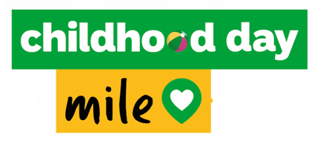Thank you,

Miss Curtis