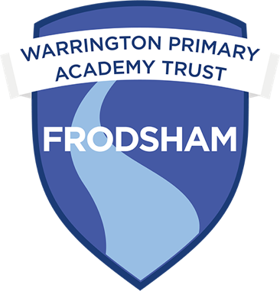
Job Advert- Mainstream Reception/Key Stage One Teacher

Frodsham Primary Academy
Ship Street
Frodsham
WA6 7PZ
Telephone Number: 01928 249840
Head of School: Mrs Gemma Callaghan

CLASS TEACHER for a Reception/Year 1
Required for September 2025. This will be a fixed term position for 12 months.

The Governors, staff and children of Frodsham Primary Academy are looking to appoint an outstanding teacher to join us in EYFS/Key Stage one. Applications are invited from enthusiastic and innovative, experienced teachers. This is a wonderful opportunity to join our fantastic team and an ideal chance for teachers wishing to develop their skills and learn from others around them. It is an exciting time for Frodsham Primary Academy as we continue our successful journey of improvement with the high performing Warrington Multi Academy Trust. We would encourage you to come and see our provision and meet our wonderful children. The successful candidate should be an inspirational classroom practitioner with the drive and determination to make a difference to all our children.

We can offer:
- A forward thinking team of staff and Governors.
- A strong ethos which focuses on the whole child.
- Enthusiastic and motivated children who love to learn.
- A strong commitment to professional development with lots of support.

We are looking for a class teacher who:
- Has a talent for making learning exciting and vibrant and who can inspire and motivate pupils
- Has high expectations about what children can achieve and has the subject knowledge to enable children to rise to these
- Has the skills to meet the needs of individuals and facilitate effective transition into mainstream education
- Has the ability to work effectively as part of a team
- Has experience of working with children with SEND
- Is forward thinking and uses their own initiative for the needs of the pupils in your care

Show rounds are encouraged and will be held on
Tuesday 25th March 9.00am and 4.00pm
Friday 28th March 9.00am and 4.00ppm
Please contact the school office 01928 249840 to book.
Closing date: Friday 4th April 9.00am
Shortlisting: Friday 4th April 3.00pm
Lesson observations and interviews: Week beginning 7th April 2025

Please complete the attached application form. If you have any questions please contact us on frodsham.office@wpat.uk or phone the school office for an informal discussion about the role.
Completed application should be sent to frodsham.head@wpat.uk
Frodsham Primary Academy is committed to safeguarding and protecting the welfare of children and vulnerable adults as its number one priority. The successful applicants will be required to apply for an enhanced disclosure from the Disclosure and Barring Service. Further details can be found at: https://www.gov.uk/government/organisations/disclosure-and-barring-service/about

