Phase 1 | Autumn 1 | Autumn 2 | Spring 1 | Spring 2 | Summer 1 | Summer 2
Year A | 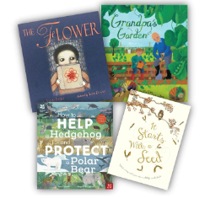  Unit C – Year 2 Living things – animals and plants. | 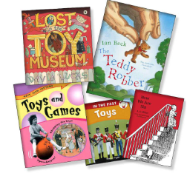  Unit A – Year 1  A living memory – toys. | 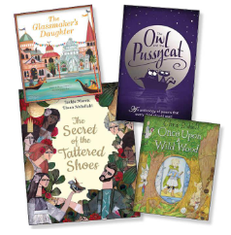  Unit B – Year 2 Fairy stories and Poetry – Classics. | 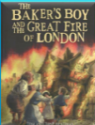  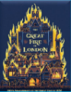  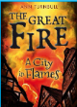  Unit E – Year 2 Beyond living memory – Great Fire of London | 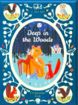    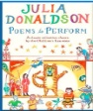  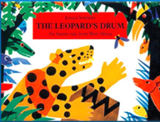  Unit D – Year 1 Traditional Tales and Poems. | 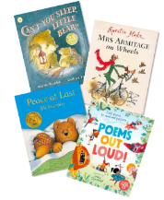  Unit F – Year 1 – Stories and Poems.
Curriculum Driver links | Pre-teach for Year A Spring Term  Retrieval from EYFS UotW | Current Autumn Term unit |  | Current Spring Term unit  Retrieval from EYFS Paddington Bear unit of work.
 | Autumn 1 | Autumn 2 | Spring 1 | Spring 2 | Summer 1 | Summer 2
Year B | 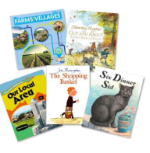  Unit C – Year 1 Locality. | 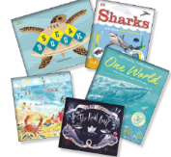  Unit A – Year 2  Rivers and Seas.  Geography seasons. | 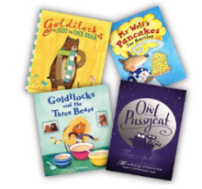  Unit B – Year 1  Fairy stories and rhymes. | 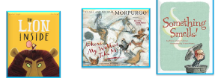  Unit E – Year 1 Animals including humans | 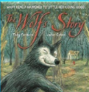  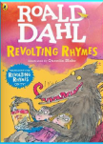  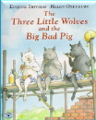  Unit D – Year 2 Traditional Tales and Poetry. | 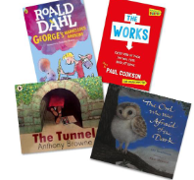  Unit F – Year 2 Stories and Plays and Poetry – Contemporary.
Curriculum Driver links | Retrieval from Year A Autumn Term | Current Autumn Term unit – human and physical features |  | Current Spring Term unit – Animals and Evolution  Retrieval from EYFS UotW

Phase 2 | Autumn 1 | Autumn 2 | Spring 1 | Spring 2 | Summer 1 | Summer 2
Year A | 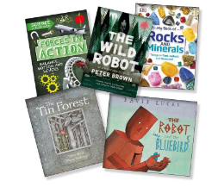  Unit A – Year 3 Forces, Magnets and Rocks. | 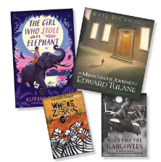  Unit B – Year 4 Reading Breadth – Stories and Poetry – Different forms. | 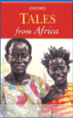  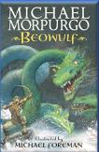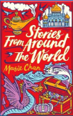  Unit D – Year 4 Myths and Legends and poetry in different forms. | 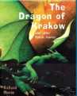  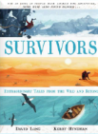  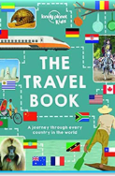  Unit E – Year 4 Europe. | 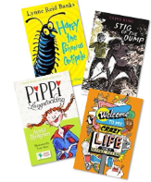  Unit F – Year 3  Stories and Plays and Poetry – Different Forms. | 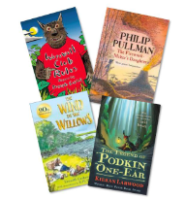  Unit F – Year 4 Stories and Plays and Poetry – Different forms
Curriculum Driver links | Pre-teach for Year B Autumn term |  | Pre-teach for Summer Term unit on Ancient Greeks | Pre-teach for Year A Summer Term
 | Autumn 1 | Autumn 2 | Spring 1 | Spring 2 | Summer 1 | Summer 2
Year B | 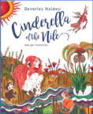  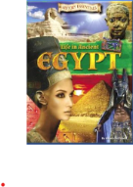  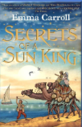  Unit E – Year 3 Egyptians. | 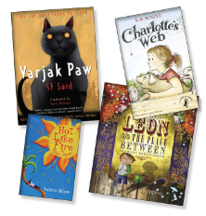  Unit B – Year 3 Reading Breadth – stories and poetry. | 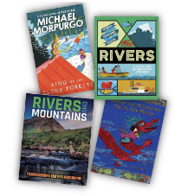  Unit C – Year 3  Rivers and Mountains. | 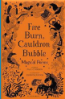  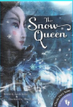  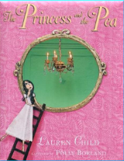  Unit D – Year 3 Reading Breadth: Fairy Stories and Poetry. | 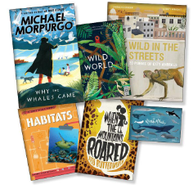  Unit A - Year 4  Living things, habitats, animals. | 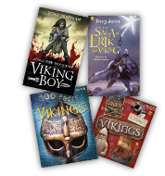  Unit C – Year 4  History – Vikings.
Curriculum Driver links | Pre-teach for Spring term |  | Retrieval for Mountains Year B Autumn Term  Current unit for Rivers. |  | Retrival for Spring Year B Animals and Evolution | Pre-teach for Phase 3 Year A Autumn term

Phase 3 | Autumn 1 | Autumn 2 | Spring 1 | Spring 2 | Summer 1 | Summer 2
Year A | 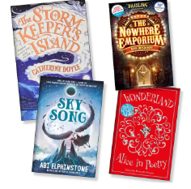  Unit B - Year 5 – Modern Fiction and Poetry – Wider Range | 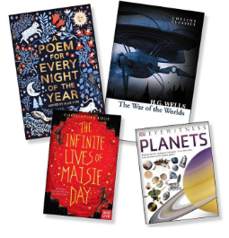  Unit A – Year 5 - Space | 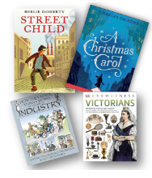  Unit C – Year 5 – The Victorians | 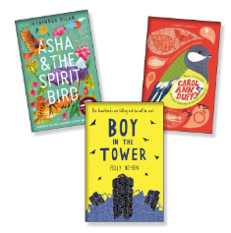  Unit B – Year 6 – Reading Breadth – Modern Fiction and Poetry | 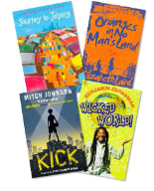  Unit F – Year 5 – Other cultures and traditions and poetry | 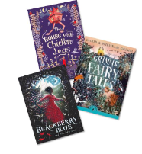  Unit F – Year 6 – Reading breadth – Traditional tales and poetry
Curriculum Driver links |  | Current Autumn term unit | Pre-teach Year B Autumn Term
 | Autumn 1 | Autumn 2 | Spring 1 | Spring 2 | Summer 1 | Summer 2
Year B | 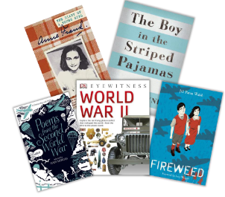  Unit A – Year 6 - War | 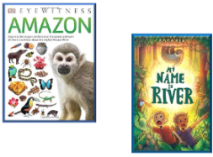  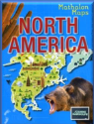  Unit E – Year 5 – North and South America - World | 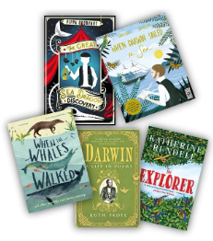  Unit C – Year 6 – Evolution and Inheritance |   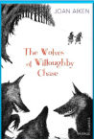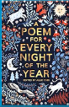  Unit D – Year 6 – Reading Breadth – Literary heritage, plays and poetry. | 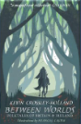  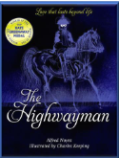  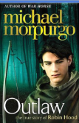  Unit D – Year 5 – Myths and Legends, plays and poetry | 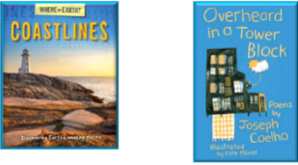  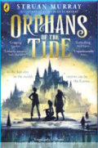  Unit E – Year 6 - Coasts
Curriculum Driver links | Current Autumn term unit | North America – Retrieval from Year A Autumn term  South America- Current Autumn term topic | Pre-teach for Year B Spring 2 Science |  | Retrieval Year A Autumn term – Ancient Greece unit | Retrieval from Year 4

