Phase One | Aut 1 | Aut 2 | Spring 1 | Spring 2 | Summer 1 | Summer 2
Year A | 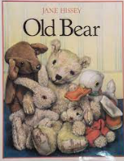  Old Bear | 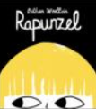  Rapunzel | 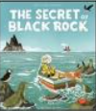  The Secret of black Rock | 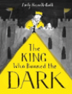  The king who banned the dark | 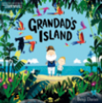  Grandad’s Island | 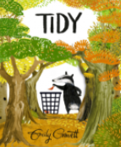Tidy
Curriculum Driver | History focus |  | Science – animals including humans. | History – Fire of London | Geography – hot and cold places | Science – Environmental
Year B | 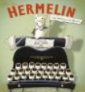  Hermelin | 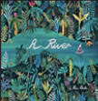  A River | 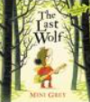  The last wolf | 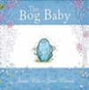  Bog Baby | 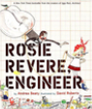  Rosie Revere Engineer | 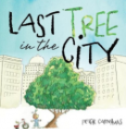  Last tree in the city
Curriculum Driver | Geography - my area |  |  | Science - living things | Science/DT Materials | Science – Environmental

Phase Two | Autumn 1 | Autumn 2 | Spring 1 | Spring 2 | Summer 1 | Summer 2
Year A | 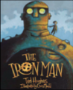  The Iron Man | 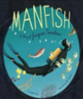  Manfish | 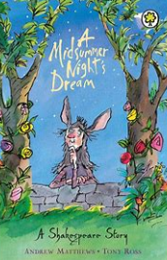  A Midsummer Night’s Dream | 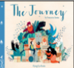  The Journey | 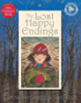  The lost happy endings | 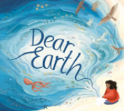  Dear Earth
Curriculum Drivers | Science | Geography | Historical Text | Geography UK |  | Science – Environmental
Year B | 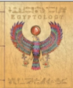  Egyptology | 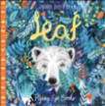  Leaf | 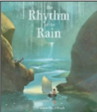  The rhythm of the rain | 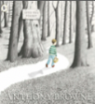  Into the forest | 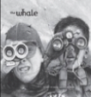  The Whale | 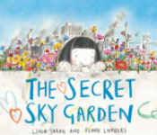  The Secret Sky garden
Curriculum Drivers | History - Early history | Science - Plants | Geography - mountains and rivers |  | Science living things

Phase Three | Autumn 1 | Autumn 2 | Spring 1 | Spring 2 | Summer 1 | Summer 2
Year A | 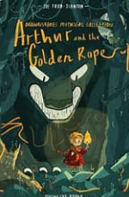  Arthur and the golden rope | 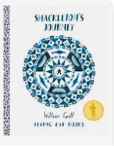  Shackleton’s journey | 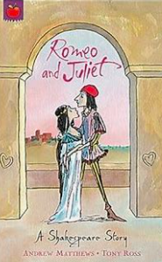  Romeo and Juliet | 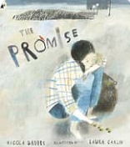  The promise | 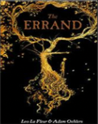  The errand | 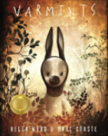  Varmints
Curriculum Drivers | History | Geography | Historical text
Year B | 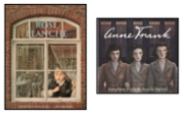  Rose Blanche / Anne Frank | 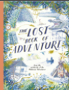  The lost book of adventure | 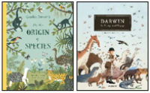  The origin of the species | 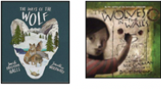  Wolves | 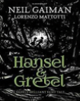  Hansel and Gretal | 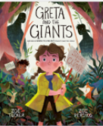  Greta and the giants
Curriculum Drivers | History | Geography South America | Science

